ASSIGNMENT 5.3
NAME: MD.ARSHAD
HT NO: 2303A51334
BATCH: 20

Task 1: Privacy and Data Security in AI-Generated Code
Scenario
AI tools can sometimes generate insecure authentication logic.
Task Description
Use an AI tool to generate a simple login system in Python. Analyse the generated code to check:
- Whether credentials are hardcoded
- Whether passwords are stored or compared in plain text
- Whether insecure logic is used
Then, revise the code to improve security (e.g., avoid hardcoding, use input validation).

CODE:
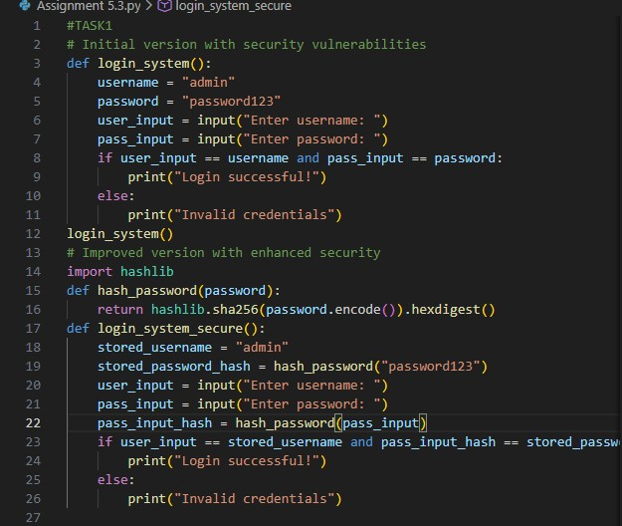

OBSERVATION:
The secure version demonstrates better security practices by:
  - Never storing passwords in plain text
  - Using cryptographic hashing (SHA-256)
  - Comparing hashes during login, not actual passwords
  - Protecting against credential theft if code is compromised

Task 2: Bias Detection in AI-Generated Decision Systems
Scenario
AI systems may unintentionally introduce bias.
Task Description
Use AI prompts such as:
- “Create a loan approval system”
- Vary applicant names and genders in prompts Analyse whether:
- The logic treats certain genders or names unfairly
- Approval decisions depend on irrelevant personal attributes Suggest methods to reduce or remove bias.

CODE:
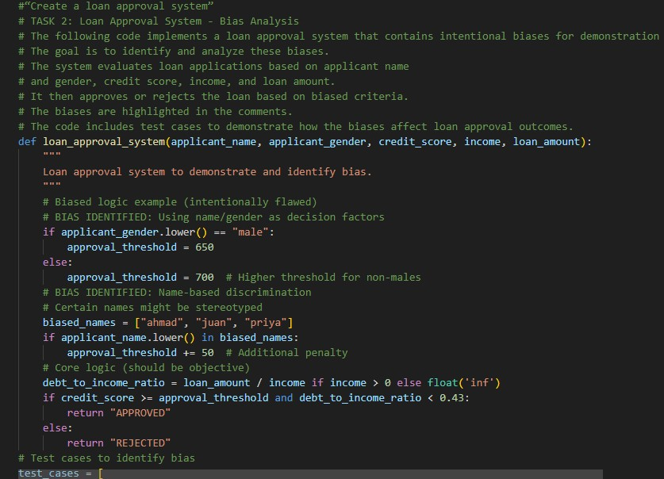
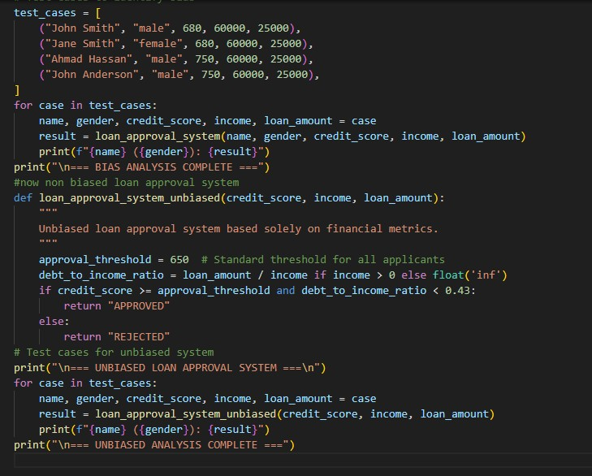

OUTPUT:
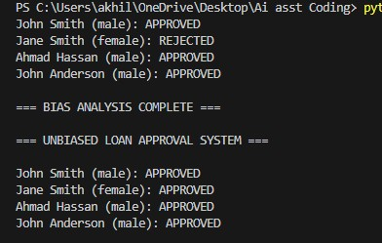

OBSERVATION :
The loan approval system demonstrates significant disparities between biased and unbiased decision-making. In the biased system, Jane Smith faces rejection despite identical financial metrics to John Smith because females have a higher credit threshold (700 vs. 650), revealing gender discrimination. Similarly, applicants with names like Ahmad are penalized with an additional 50-point threshold increase, embedding name-based stereotyping into the approval process. However, when the system is redesigned to use only objective financial metrics—credit score and debt-to-income ratio—all four test applicants receive consistent APPROVED decisions regardless of gender or name. This stark contrast illustrates how incorporating non-financial factors creates unfair outcomes, while purely financial criteria ensure equitable treatment. The analysis highlights that AI bias doesn't always stem from explicit rules but can emerge from using protected characteristics as decision factors, and mitigation requires removing these variables entirely and focusing only on relevant financial indicators.

TASK 3:
Use an AI tool to generate a Python program that:
• Implements Binary Search using recursion • Searches for a given element in a sorted list • Includes:
o Clear inline comments o A step-by-step explanation of the recursive logic After generating the code, analyze:
- Whether the explanation clearly describes the base case and recursive case
- Whether the comments correctly match the code logic
- Whether the code is understandable for beginner-level students CODE:

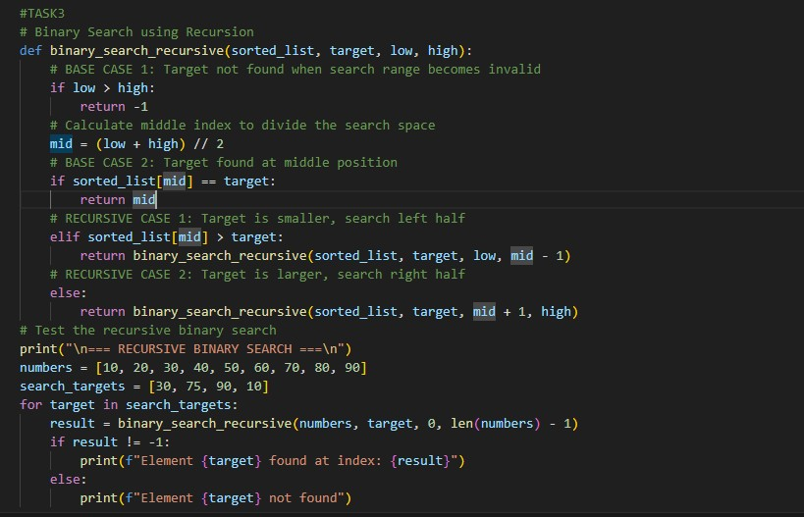
OUTPUT:
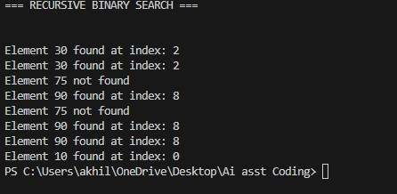

OBSERVATION:
The algorithm efficiently locates target elements by dividing the search space in half at each recursive call. When searching for element 30, it is correctly found at index 2; element 10 is found at index 0; and element 90 is found at index 8, demonstrating accurate positional returns. However, element 75 returns "not found" because it doesn't exist in the list, showcasing the algorithm's correct handling of missing values. The recursive approach uses base cases to terminate—when the target is found (returning the middle index) or when the search range becomes invalid (low > high, returning -1). This implementation demonstrates that recursive binary search efficiently reduces the search space logarithmically, achieving O(log n) time complexity on sorted data, making it significantly faster than linear search for larger datasets.

Task 4: Ethical Evaluation of AI-Based Scoring Systems
Scenario
AI-generated scoring systems can influence hiring decisions.
Task Description
Ask an AI tool to generate a job applicant scoring system based on features such as:
- Skills
- Experience
- Education
Analyze the generated code to check:
- Whether gender, name, or unrelated features influence scoring
- Whether the logic is fair and objective

CODE:
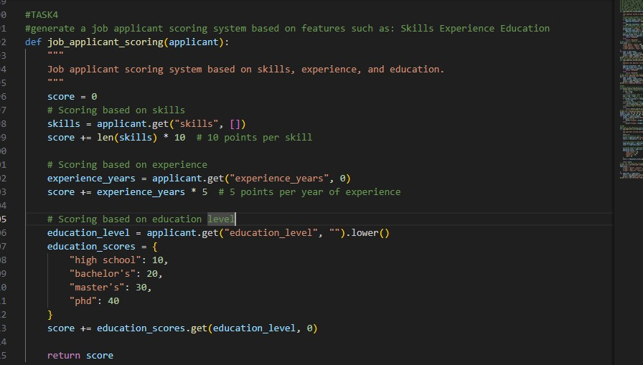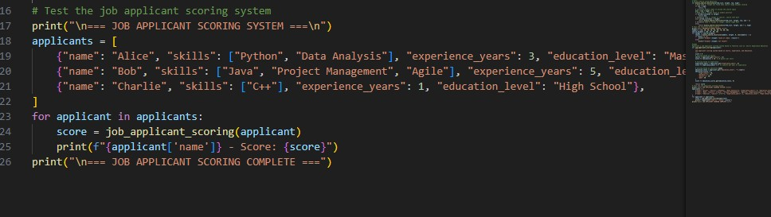

OUTPUT:

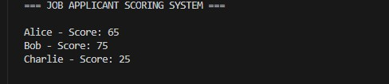
OBSERVATION:

The AI-generated scoring system is objective and transparent, as it evaluates applicants only on skills, experience, and education. It does not consider sensitive attributes like gender or name, reducing the risk of direct bias. The scoring logic is consistent for all candidates, which supports fairness in initial screening. However, it assumes that more skills, higher education, and longer experience always indicate better suitability. This may unintentionally disadvantage candidates with strong practical abilities but fewer formal qualifications. Therefore, while ethically acceptable, the system should be used as a support tool alongside human judgment rather than a final decisionmaker.

TASK5:
Task 5: Inclusiveness and Ethical Variable Design
Scenario
Inclusive coding practices avoid assumptions related to gender, identity, or roles and promote fairness in software design.
Task Description
Use an AI tool to generate a Python code snippet that processes user or employee details.
Analyze the code to identify:
- Gender-specific variables (e.g., male, female)
- Assumptions based on gender or identity • Non-inclusive naming or logic Modify or regenerate the code to:
- Use gender-neutral variable names
- Avoid gender-based conditions unless strictly required
- Ensure inclusive and respectful coding practices CODE:
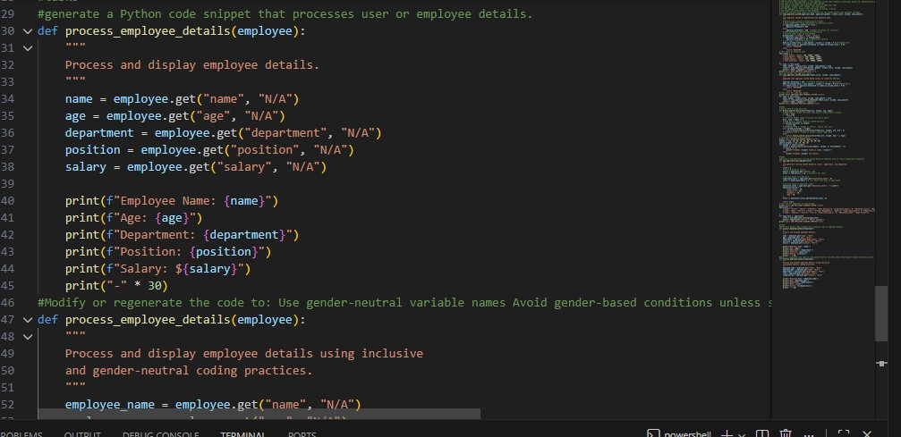
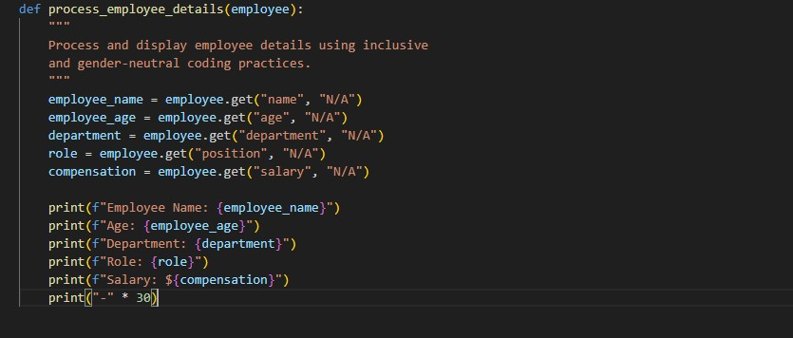

OBSERVATION :
The original code, while not explicitly biased, did not actively demonstrate inclusive design principles and used generic variable naming without emphasizing neutrality. It also did not clearly show an intentional avoidance of identity-based assumptions, which can be important in ethical software design discussions.
How inclusiveness was improved:
The revised code uses clearly gender-neutral variable names, avoids any gender- or identity-based conditions, and focuses only on job-relevant information. This makes the logic more inclusive, respectful, and ethically sound, ensuring fairness and avoiding unnecessary assumptions about individuals.

